WEEK-2
PL/SQL PROGRAMMING SOLUTIONS
Exercise 1: Control Structures
CODE:
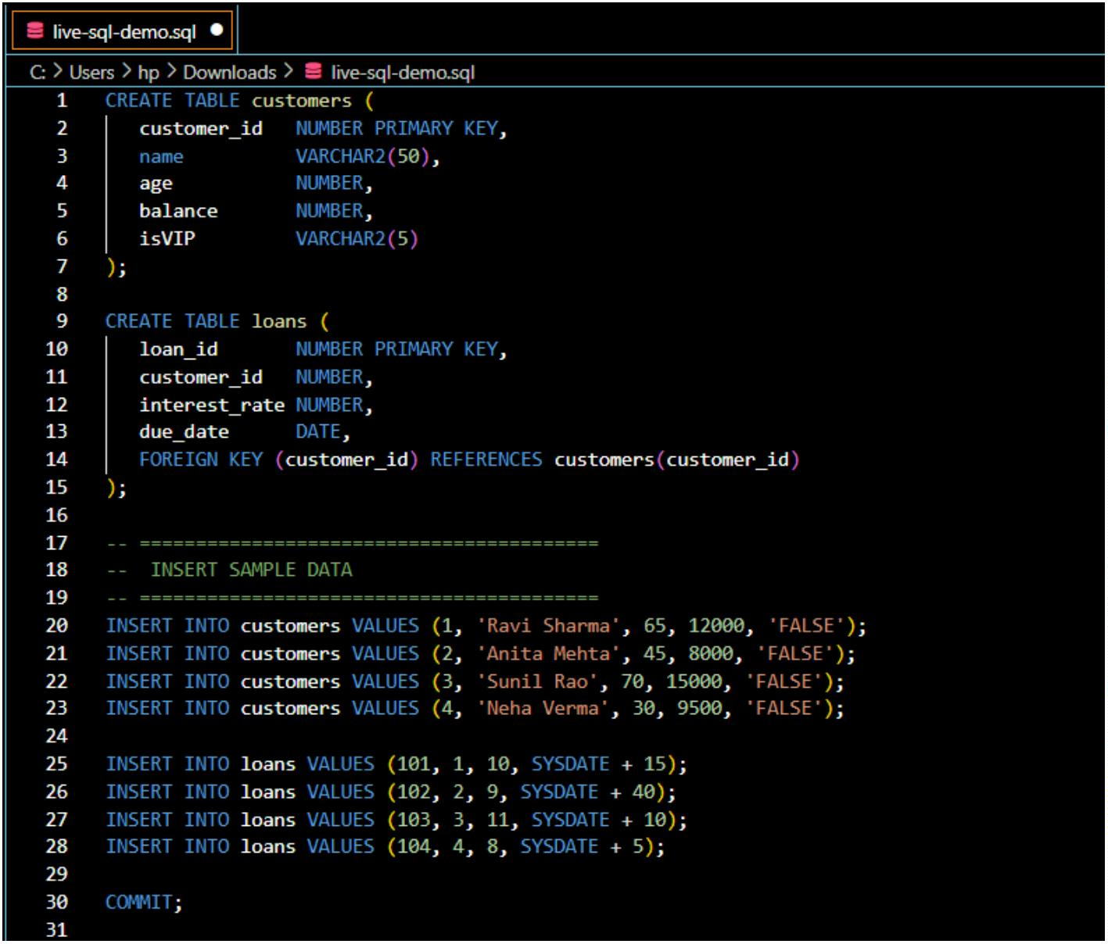

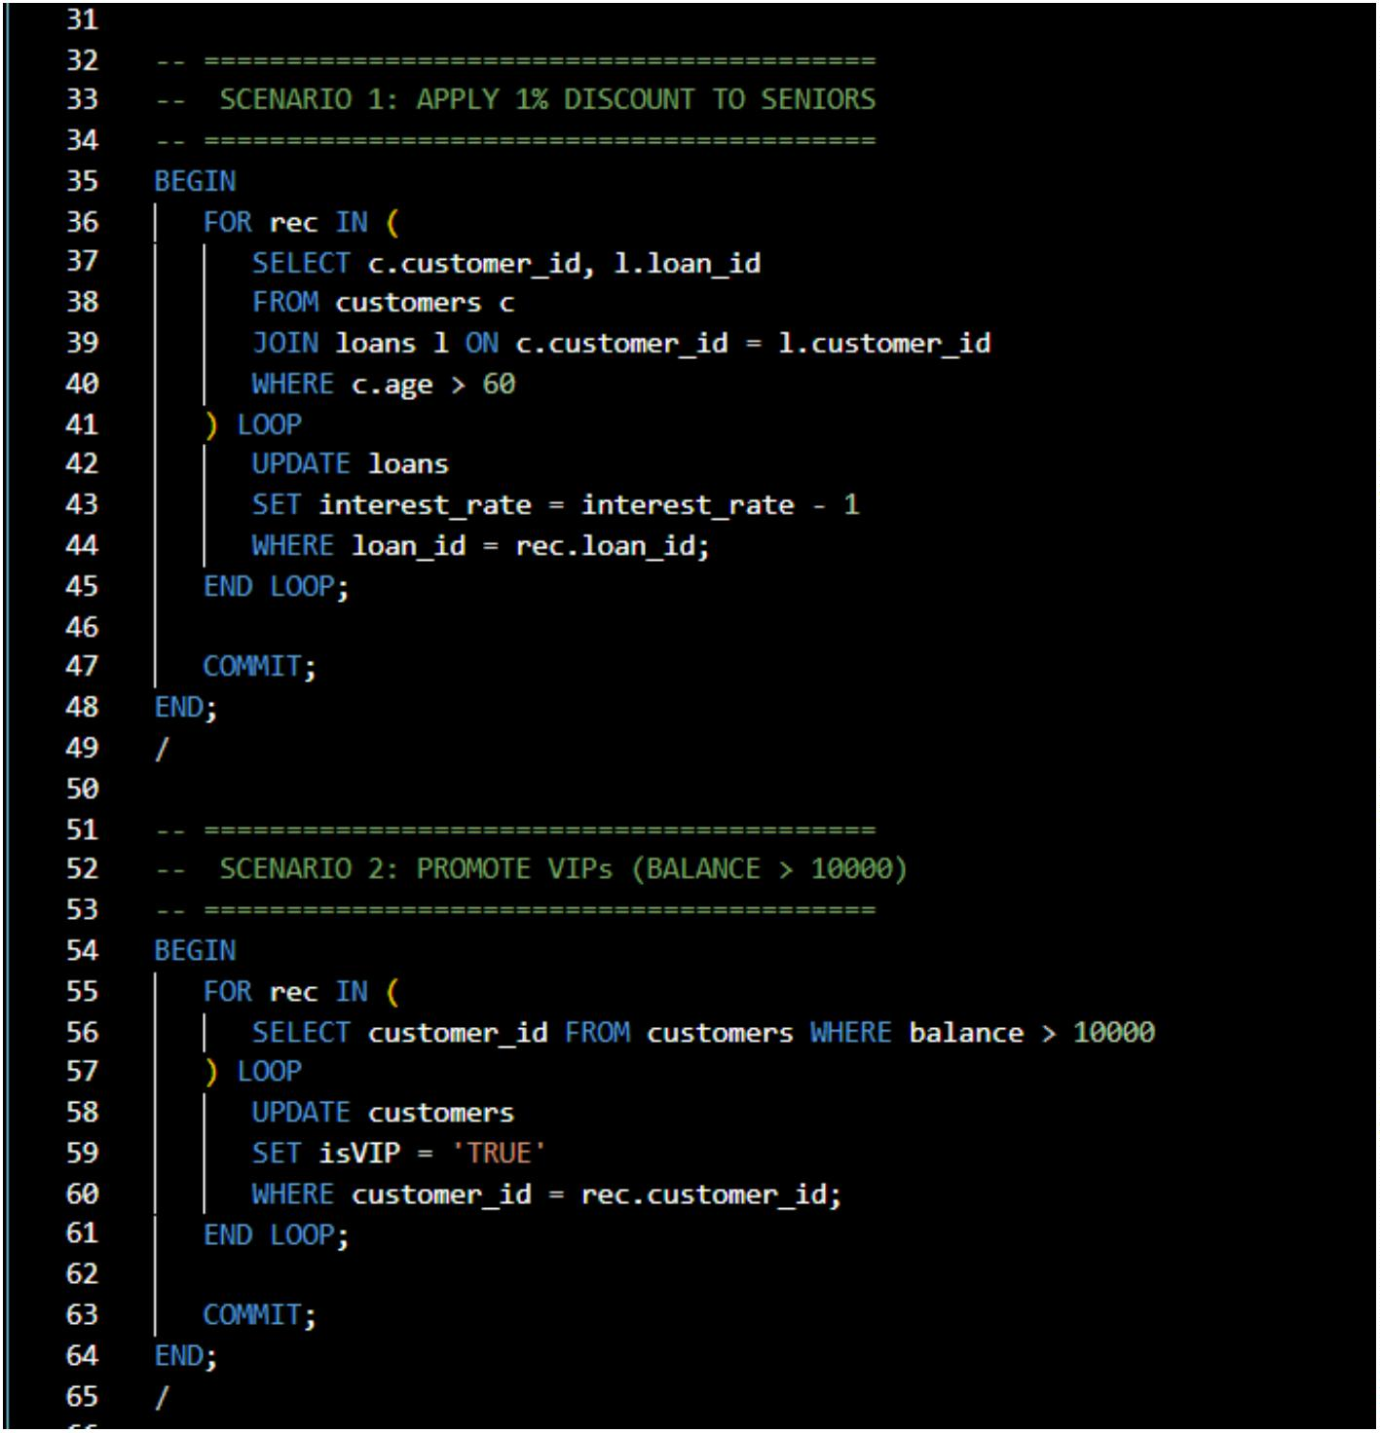

OUTPUT:
SCENARIO 1-
SCENARIO 2:
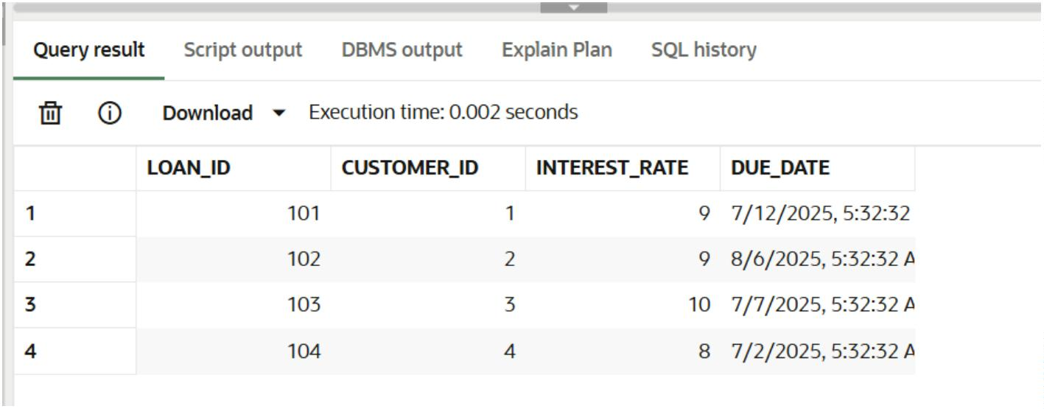
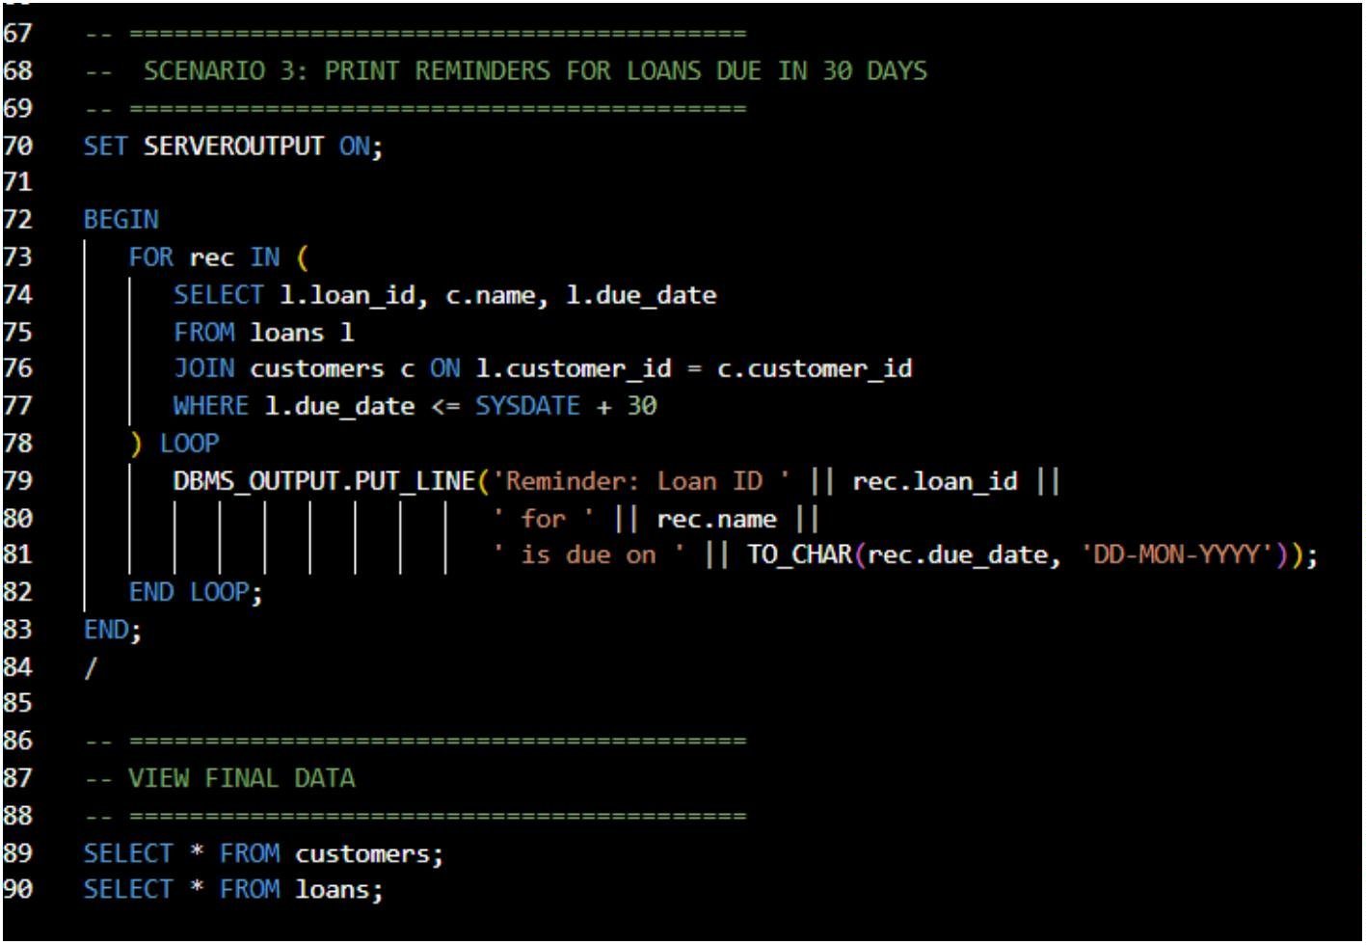

SCENARIO 3:
Exercise 3: Stored Procedures
CODE:
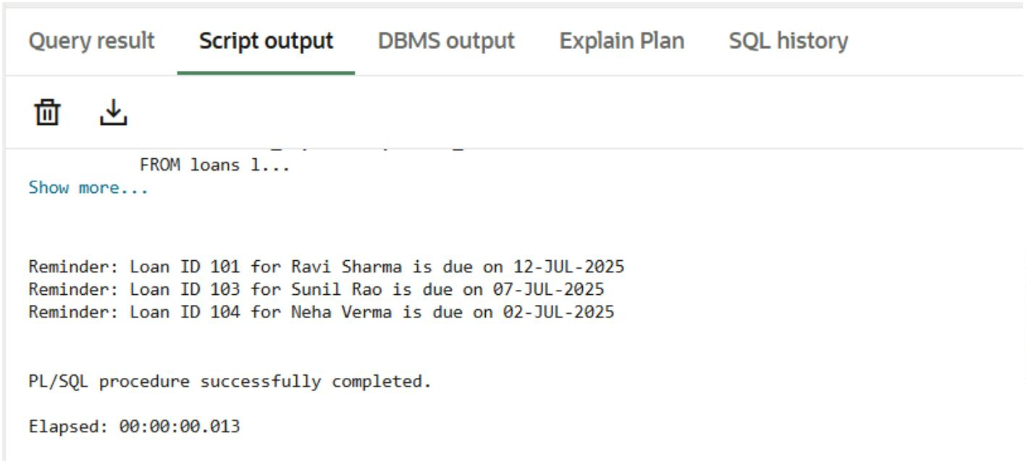
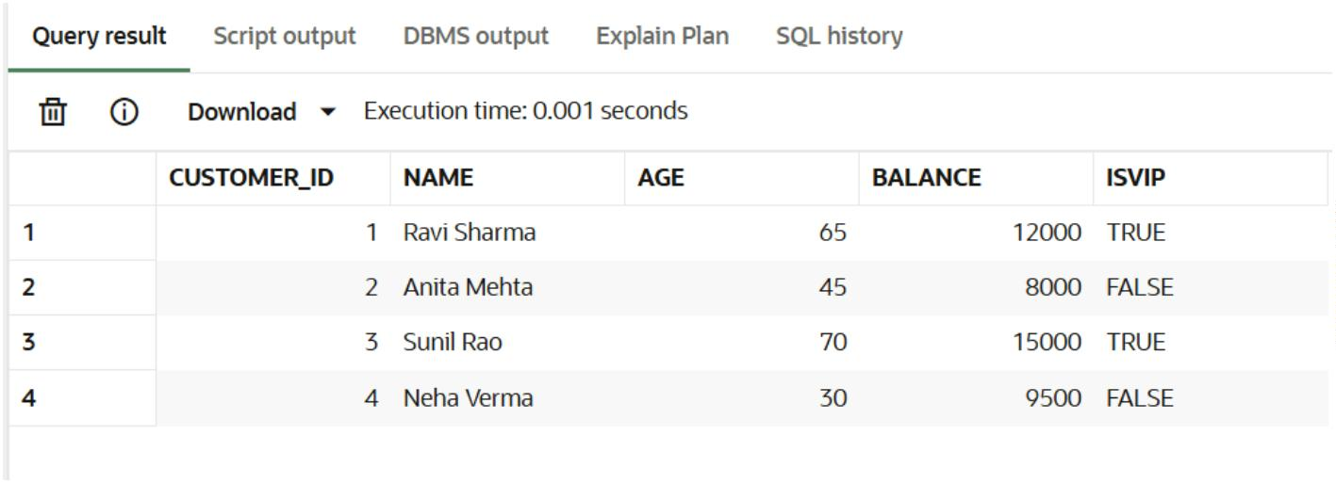

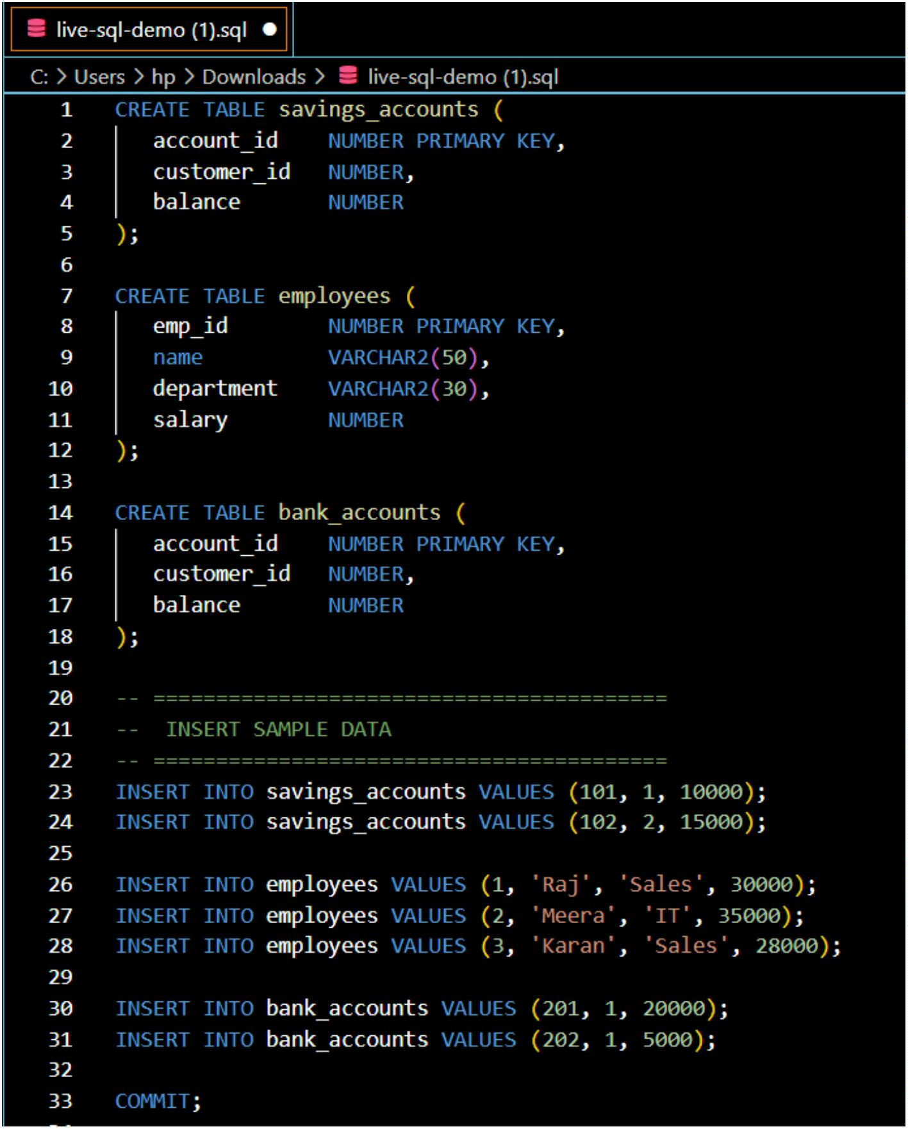

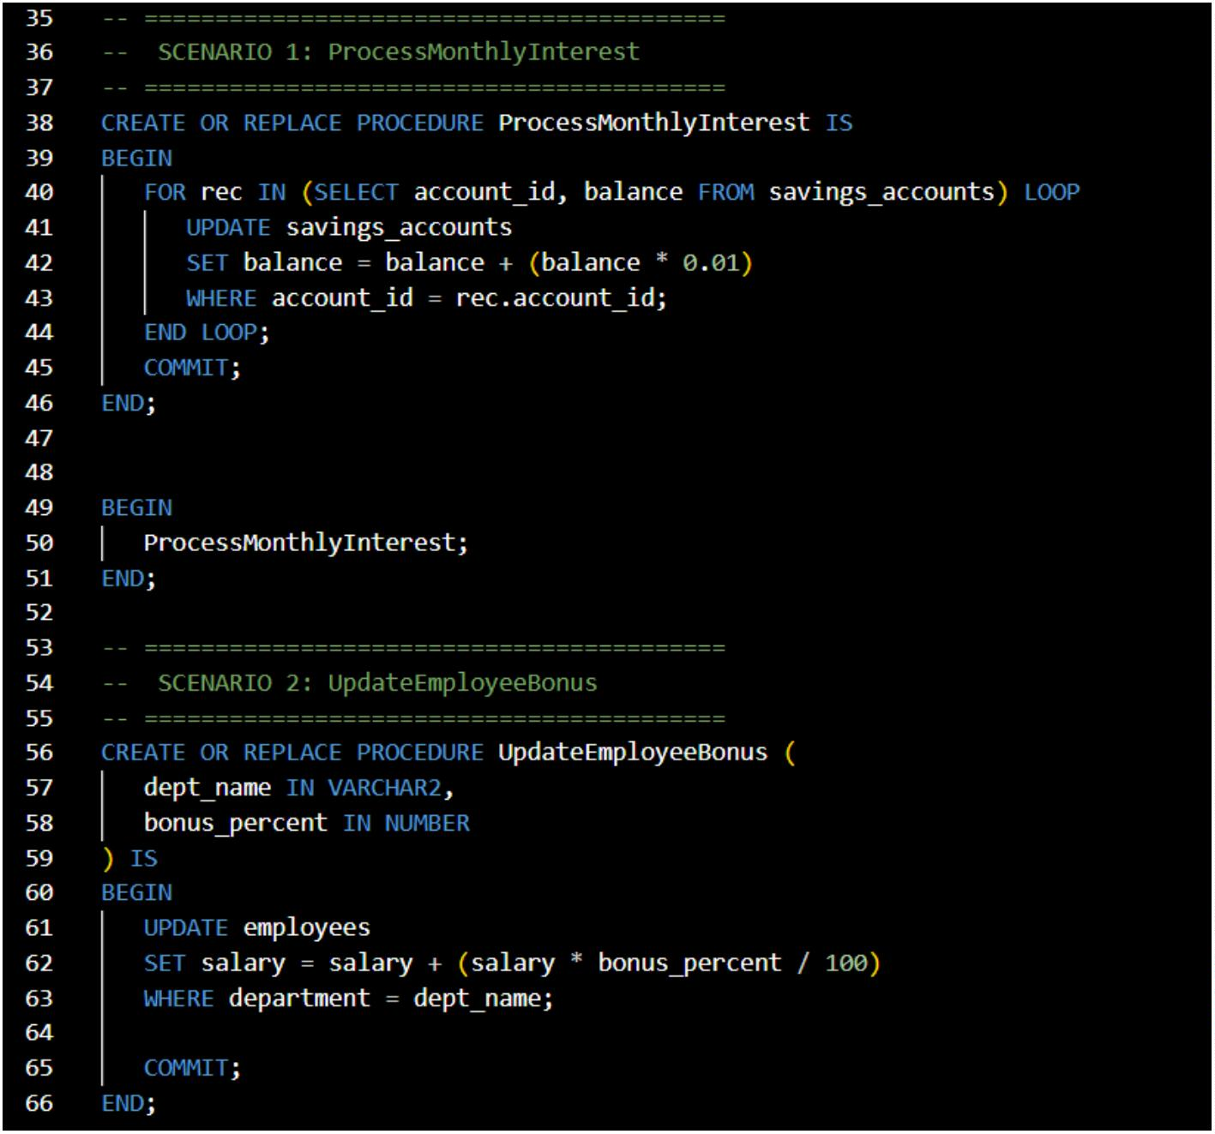

OUTPUT:
SCENARIO 1:
Before Execution:
After Execution
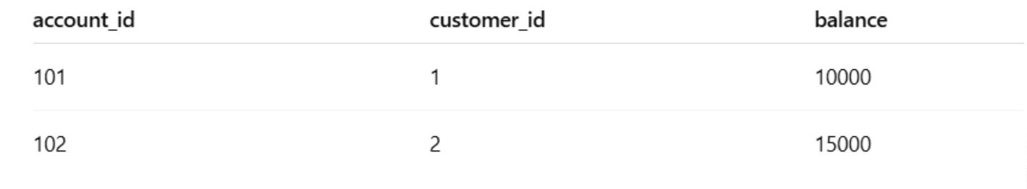
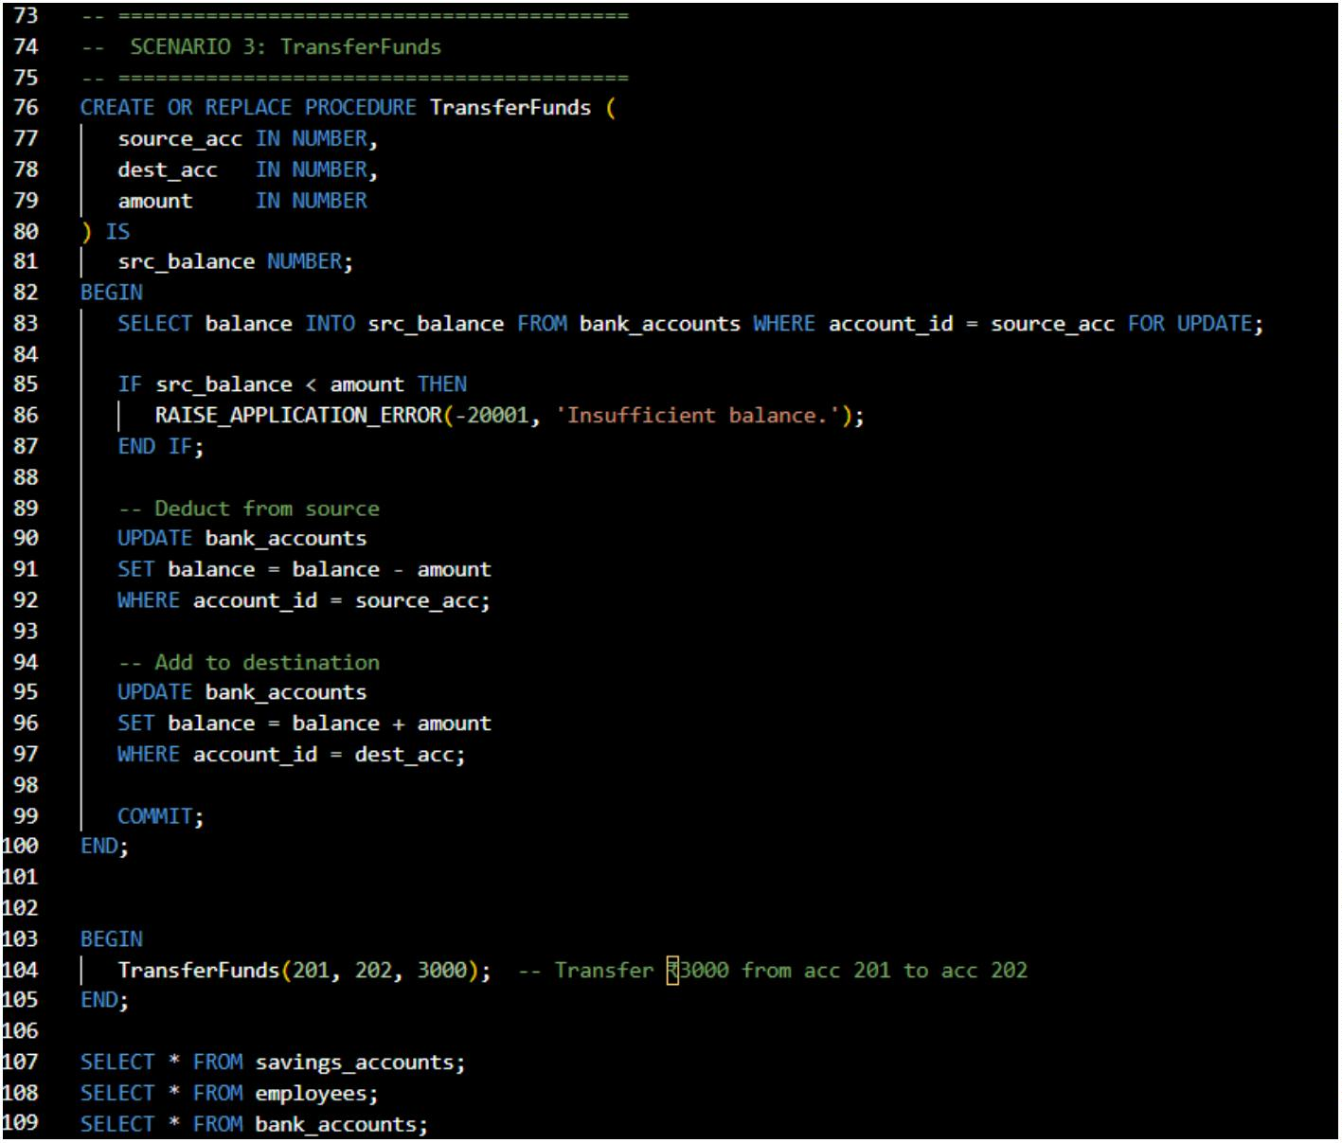

SCENARIO 2:
Before Execution:
After Execution:
SCENARIO 3:
Before Execution:
After Execution:
